Running Head: Phase II Document

James Boehm, Marcus Jones, David Markowski

Ray Gutierrez, Andrew Delgado, David Batdorf

November 30, 2019

CMSC 495

Professor Terrence Mentzos

User Guide

Food 4 Friends is a web application that connects those in need of food with those who are able to provide for others

Installation/Usage

The application is still in development. It currently runs through a hosted service when Node.js. Therefore, installation of Node.js is a prerequisite.

⦁ Visit ⦁ www.nodejs.org/en and download and install the current LTS version.

⦁ Extract the zip file to a destination folder of your choice.

⦁ Open terminal or PowerShell window at the project root folder.

⦁ Type the command npm run serve

⦁ Navigate to the backend server root folder

⦁ Type the command npm run start

⦁ The application will compile and become hosted at <http://localhost:8080> or

<http://you_private_ip:8080>

⦁ Going to your browser and pointing to one of those URLs will launch the application

Phase I

Phase I is coding the navigation of the website and using simple hard-coded data

Phase II

Phase II is integration of database aspects to the service, and cleaning up of the user interface with the addition of pending transactions, and the MeetUp navigation menu.

Phase III

Phase III will be the final polish of all user interface elements, and the inclusion of Google’s sign in functionality, and Google’s map location services.

Attached are pictures of the product thus far

Front Page:



Choosing User type:

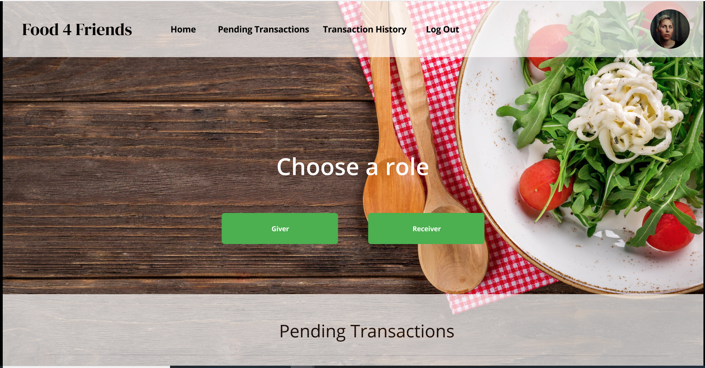

Posting a Food Type: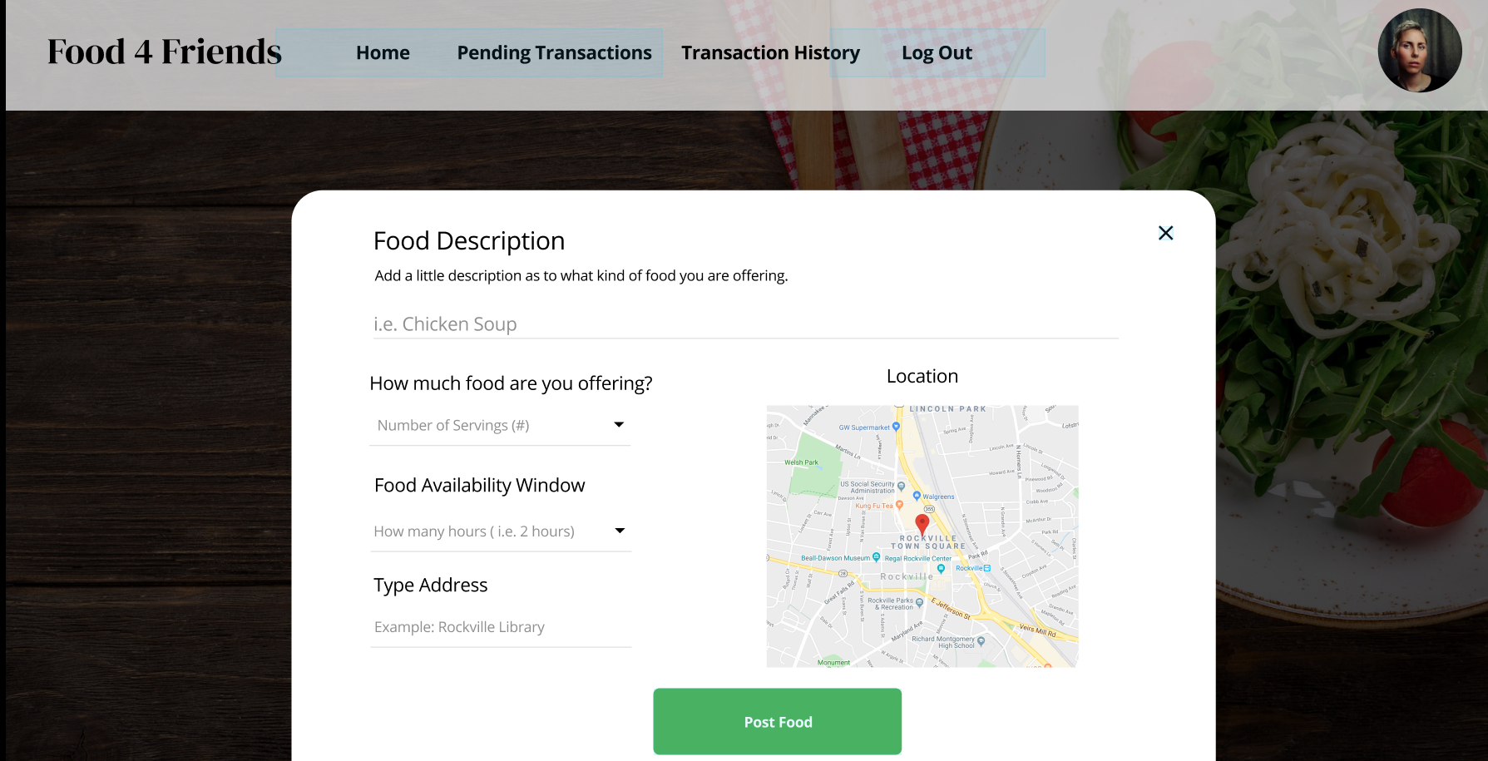

Pending Transactions:

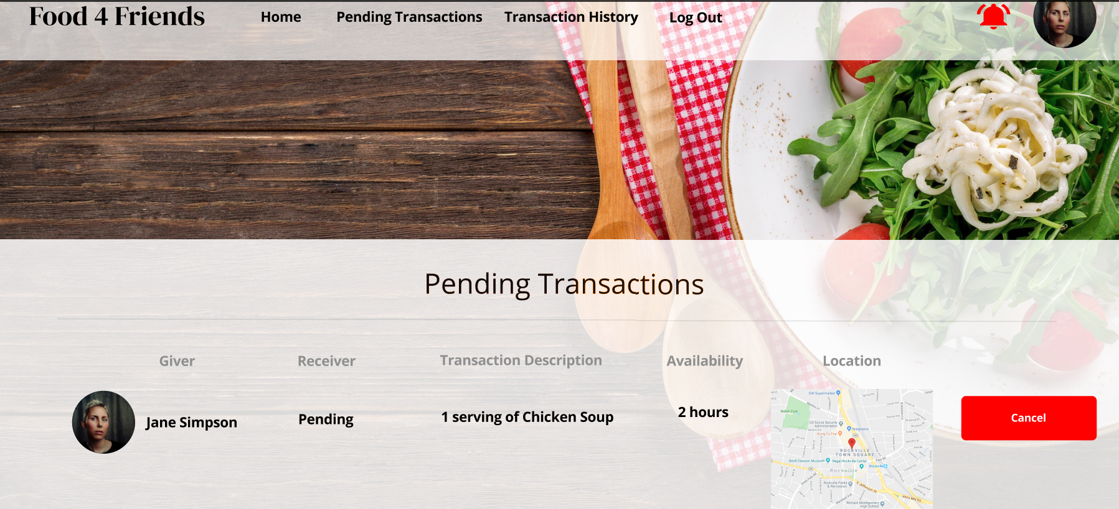

Meet Up Request:

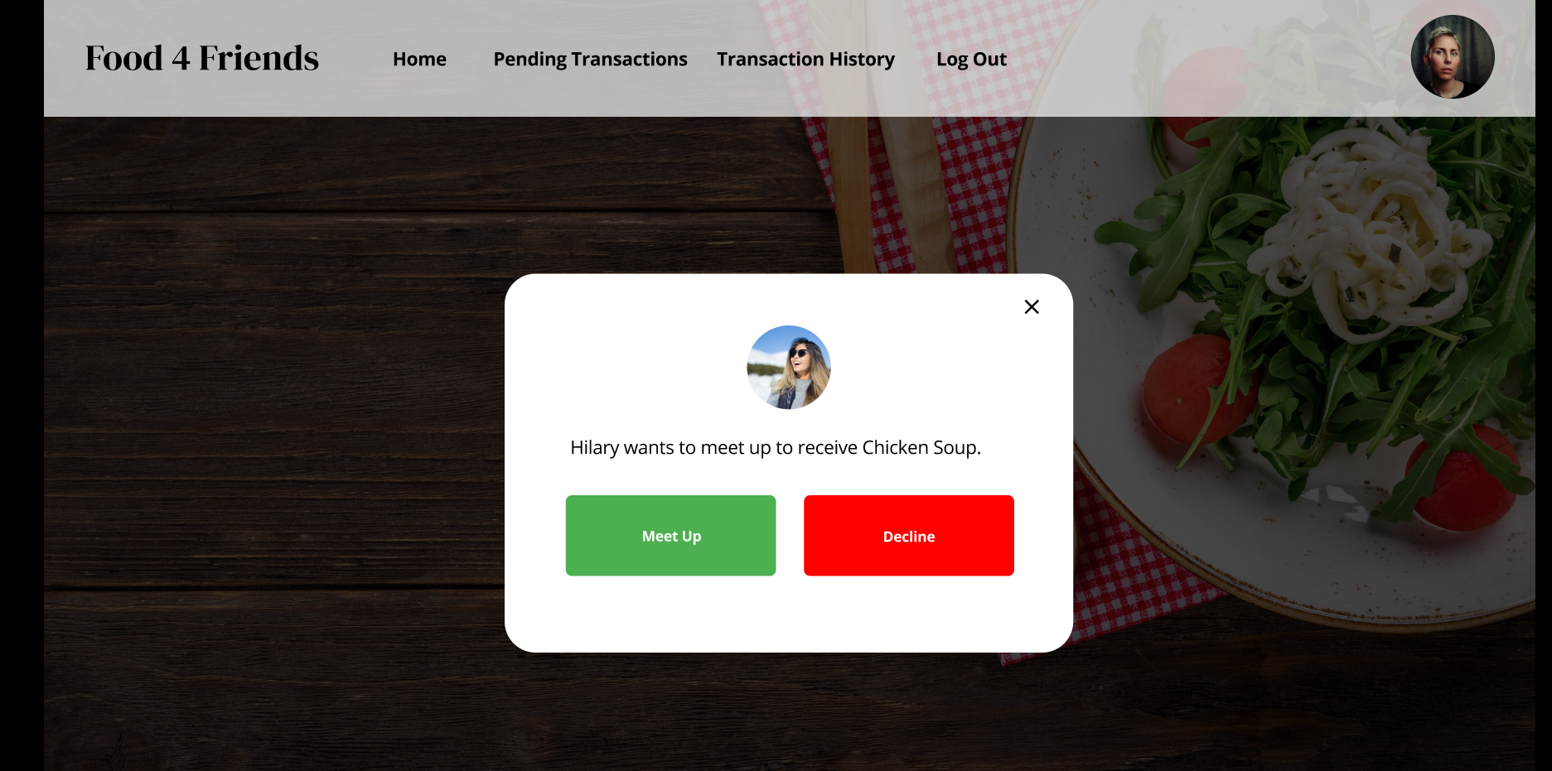

Transaction History:

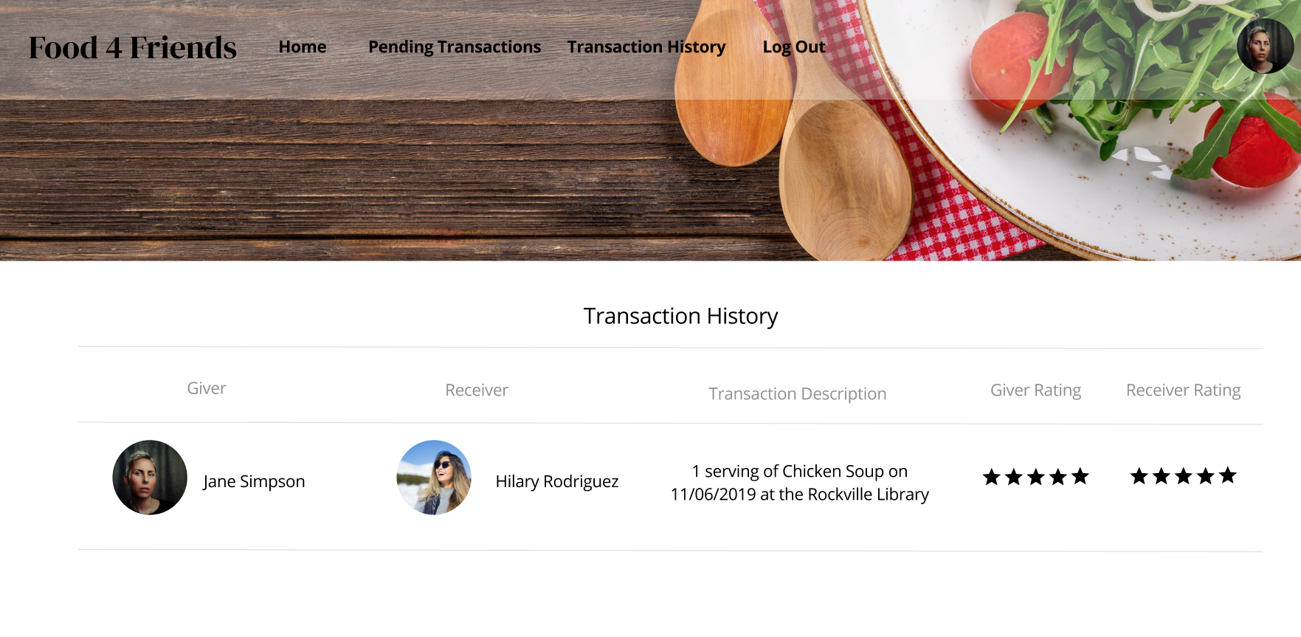

Nearby Food Offerings: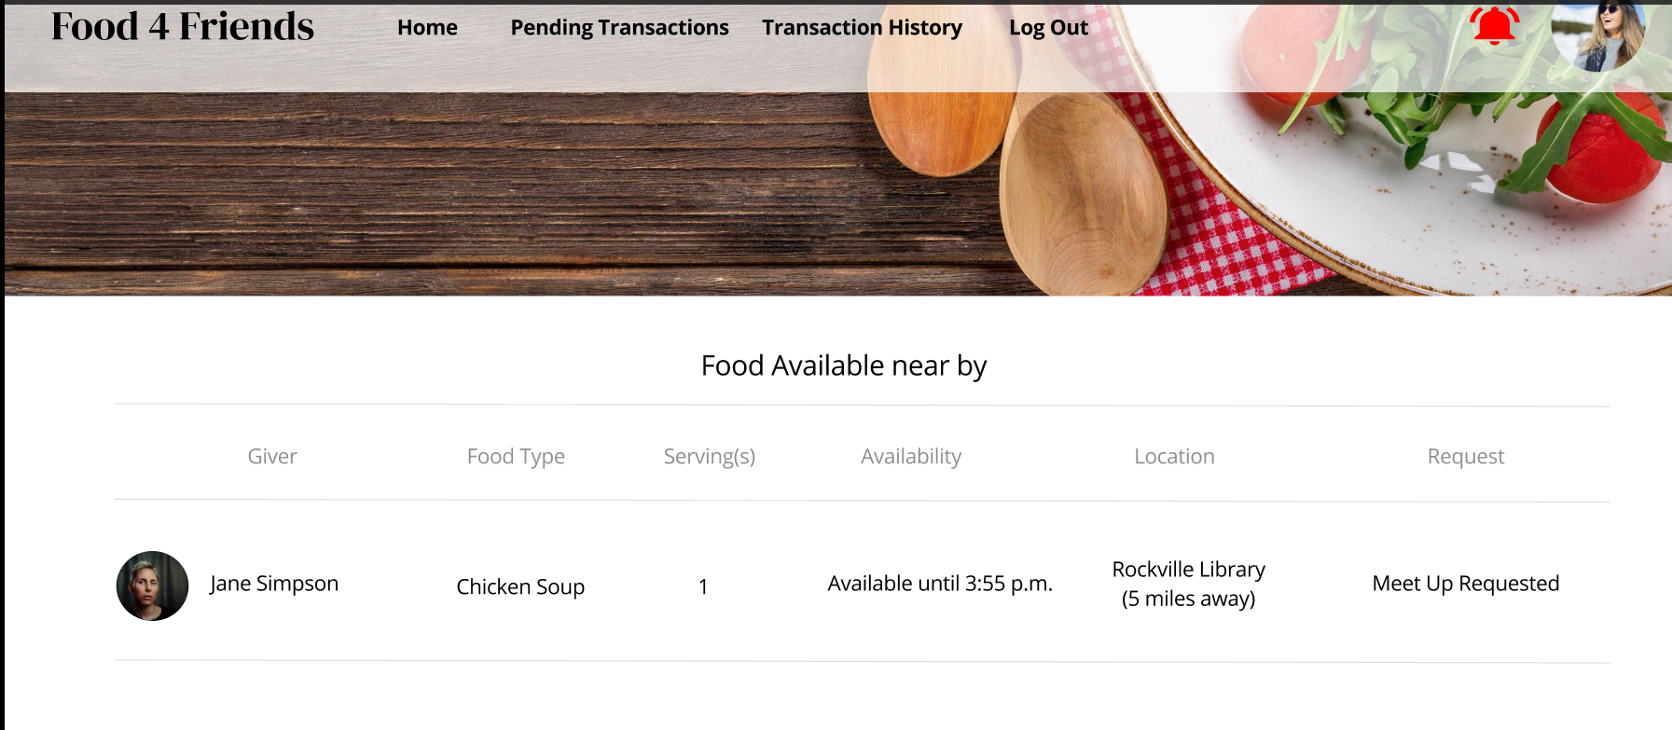

Phase II of the development effort will be taking place over the 6th weekly sprint for the “Food 4 Friends” project. Phase I focused on creating the individual pages and integrating core frameworks. Phase II will be used to polish the GUI, and further integrate external features.

The original milestones for this sprint are to have a fully navigable application, and to have the external database fully integrated into the product. Some of the sprint goals have been met, the database has been fully integrated for user sign-in, but some modifications still need to be made to store and pull food items from the database, in addition to several polishing touches to the GUI. Additions to the GUI are a button to change the user’s current role from Giver to Receiver and vice versa, and a panel on the GUI to view transactions that you have entered, but have not yet been canceled, or completed.

The project will need some talent management to remain on schedule, with phase III being dedicated to integrating the Google sign in and Google maps. The project, running Lean Kanban form of agile methodology focus of delivering a minimum deliverable product, and then polish the product with features as time allows.

The project is currently performing extremely well on multiple environments, following the project plan of maintaining a big O time performance of O(1). The current risk management plan of discovering correcting faults during development has proven to be extremely beneficial, allowing team members to actively coordinate and correct bugs. Two poorly performing functions were identified, and tasked for correction during Phase II. The first being the ability for users to switch modes while inside the application. This will remove the need for users to full reboot the application in order to change from “Giver” mode to, “Receiver” mode. The second poorly performing aspect, was the ability of the user. The overall cost project of the project has remained consistent, though unused time resources have been depleted this sprint, and time for the later end of the project has been reallocated into the development phase. Much progress has been made to the goal of full database integration, and it should still be achievable under the current budget.

Security is extremely important to us at “Food 4 Friends”, both for our users and for our project resources. To achieve this all code delivered to the end users will be compiled, obfuscating security details. To ensure data communicated through the application is secure, 256 bit encryption will be utilized for all external communications. The connection to the database will be secured by only providing end users with compiled code, preventing them from viewing security details, and database connection details.

Current user interface decisions were based on test user interactions, conducted by the members of the team, who are not assigned to user interaction roles. The look and flow of the app, is focused on maximizing simplicity, while also providing maximum functionality, and integrating a logical flow for user interaction.

Table 1.

Original Cost and Time Schedule

|  |  |  |  |  |  |  |  |
| --- | --- | --- | --- | --- | --- | --- | --- |
| Sprint | Project Manager hours | User Interaction Engineer  hours | Technical Writer  hours | Software Engineer  hours | Test Engineer  hours | Integration Engineer  hours | Total Cost  (hourly rates from table 3) |
| 1 | 3 | 1 | 1 | 1 | 1 | 1 | ‭$364.18‬ |
| 2 | 5 | 1 | 3 | 1 | 1 | 2 | ‭$589.03‬ |
| 3 | 3 | 5 | 3 | 3 | 5 | 2 | $‭932.35‬ |
| 4 | 3 | 3 | 2 | 6 | 2 | 2 | $‭827.79‬ |
| 5 | 3 | 3 | 3 | 6 | 3 | 4 | $‭1,007.4‬0 |
| 6 | 3 | 3 | 3 | 6 | 3 | 4 | $‭1,007.4‬0 |
| 7 | 3 | 3 | 3 | 6 | 3 | 4 | $‭1,007.4‬0 |
| 8 | 5 | 3 | 5 | 1 | 5 | 2 | ‭$929.15‬ |
| Total | 28 | 22 | 23 | 30 | 23 | 21 | $‭6,664.7‬0 |

Table 2.

Original Cost and Time Schedule

|  |  |  |  |  |  |  |  |
| --- | --- | --- | --- | --- | --- | --- | --- |
| Sprint | Project Manager hours | User Interaction Engineer  hours | Technical Writer  hours | Software Engineer  hours | Test Engineer  hours | Integration Engineer  hours | Total Cost  (hourly rates from table 3) |
| 1 | 3 | 1 | 1 | 1 | 1 | 1 | ‭$364.18‬ |
| 2 | 5 | 1 | 3 | 1 | 1 | 2 | ‭$589.03‬ |
| 3 | 3 | 5 | 3 | 3 | 4 | 1 | $‭841.65‬ |
| 4 | 3 | 3 | 2 | 4 | 2 | 2 | $‭727.89‬ |
| 5 | 3 | 4 | 3 | 7 | 4 | 5 | $‭1,188.65‬ |
| 6 | 3 | 4 | 3 | 7 | 3 | 4 | $‭1,097.95‬ |
| 7 | 3 | 2 | 3 | 6 | 3 | 5 | $‭1,013.75‬ |
| 8 | 5 | 2 | 5 | 1 | 5 | 1 | $‭841.6‬ |
| Total | 28 | 22 | 23 | 30 | 23 | 21 | $‭6,664.7‬0 |

Table 3.

Hourly Rates for Project team

based on glassdoor.com average salaries for

Washington DC locality.

|  |  |
| --- | --- |
| Role | Expected hourly cost |
| Project Manager | $46.99 |
| User Interaction Engineer | $40.60 |
| Technical Writer | $31.96 |
| Software Engineer | $49.95 |
| Test Engineer | $43.75 |
| Integration Engineer | $46.95 |

References

Company Salaries. (n.d.). Retrieved from <http://www.glassdoor.com/salaries>.